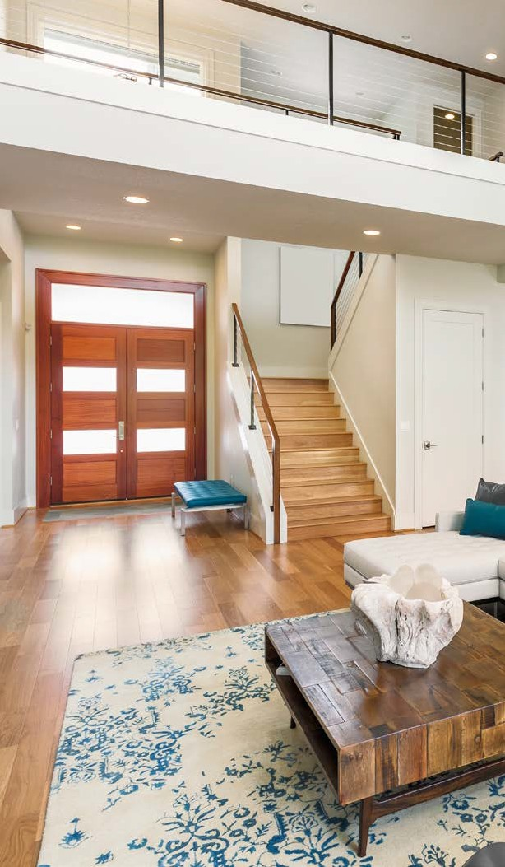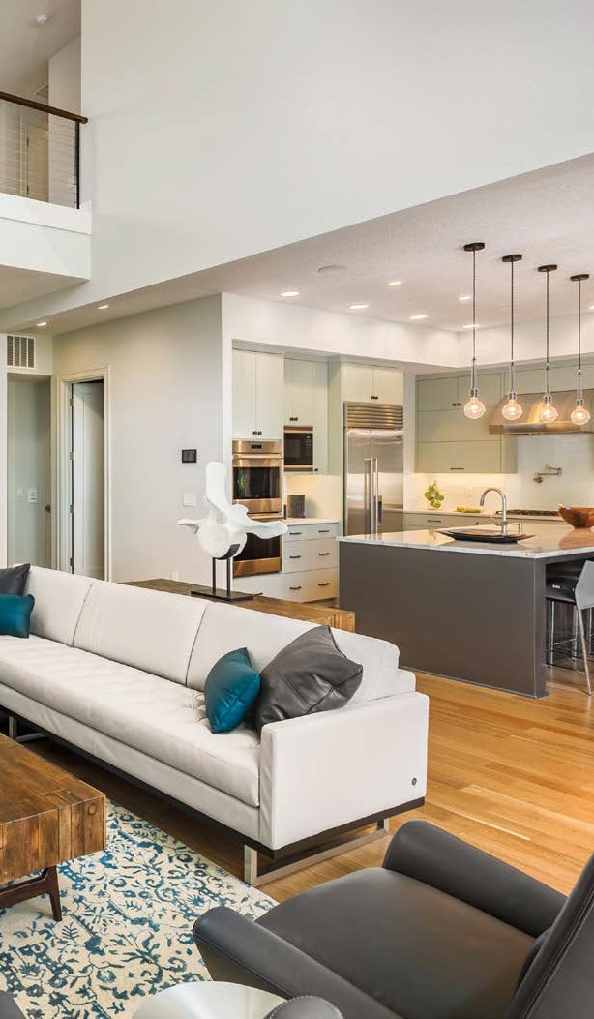



12707

EDGEWOOD

DRIVE

*Atlanta, GA 30345*



**NORMAN &**

**ASSOCIATES**

**REAL ESTATE SOLUTIONS**



JEREMY NORMAN

Broker/CEO | Norman & Associates

CCIM, CLHMS

205.281.3934

470.223.1981

[jnorman@normanliving.com](mailto:jnorman@normanliving.com)

www.normanliving.com

2295 Parklake Drive NE, Suite 440

Atlanta, GA 30345









*For an exclusive and detailed list of specifications for this magnificent home, contact me today at 205.281.3934.*

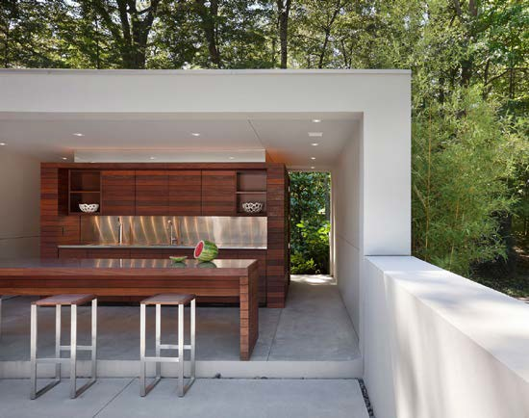

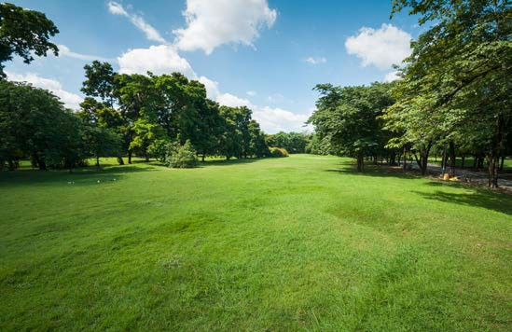



### PRESENTED BY

JEREMY

NORMAN

*Your Luxury Real Estate Specialist*

**NORMAN &**

**ASSOCIATES**

**REAL ESTATE SOLUTIONS**

Published by REAL Marketing (REM) | [www.REALMarketing4You.com](http://www.REALMarketing4You.com/) | 858.952.4280 | ©2019

This brochure is not intended to solicit properties already listed for sale nor intended to cause a breach of an existing agency relationship. E&OE covered.

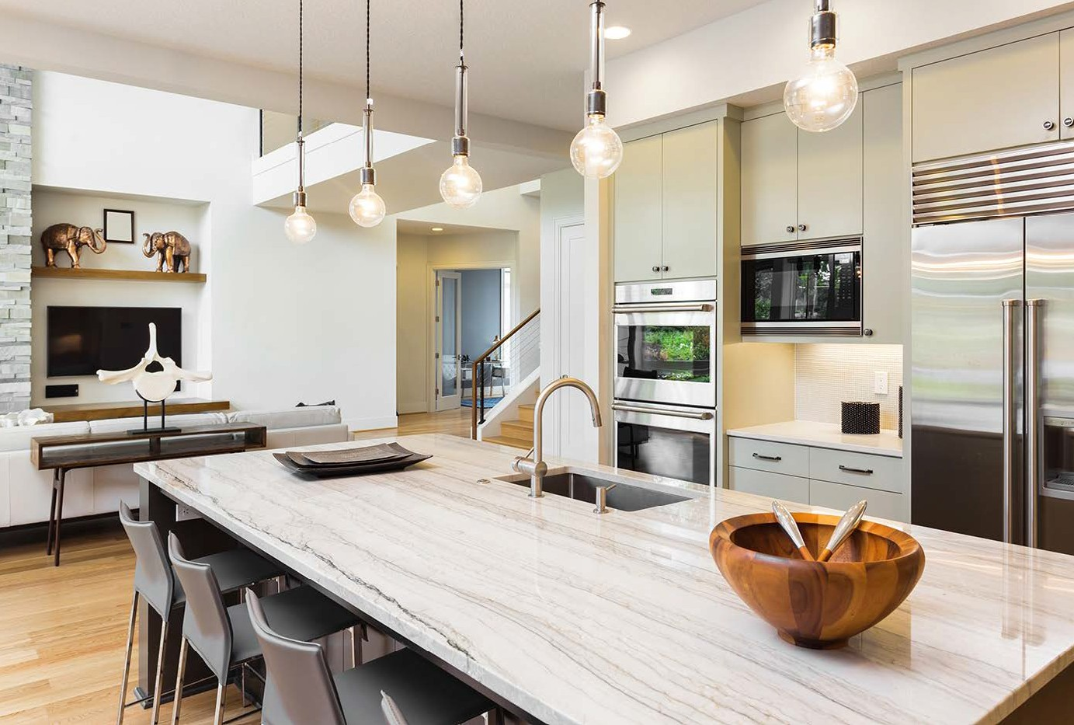

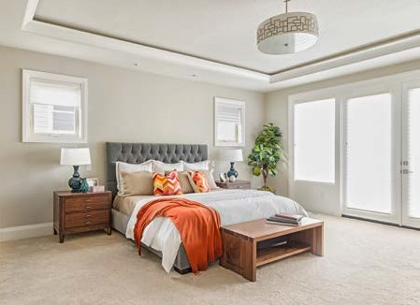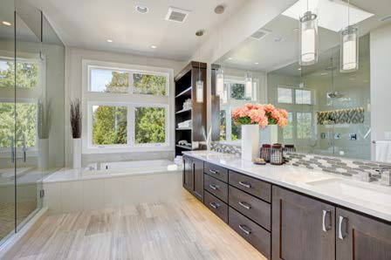

# PERFECT

CONTEMPORARY

*Masterpiece*

## 12707 EDGEWOOD DRIVE

ATLANTA, GA 30345

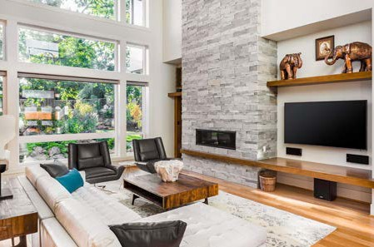

### OFFERED AT $1,897,000

6,970

Square Foot Lot

4,321

Square Feet

3

Baths

5

Beds

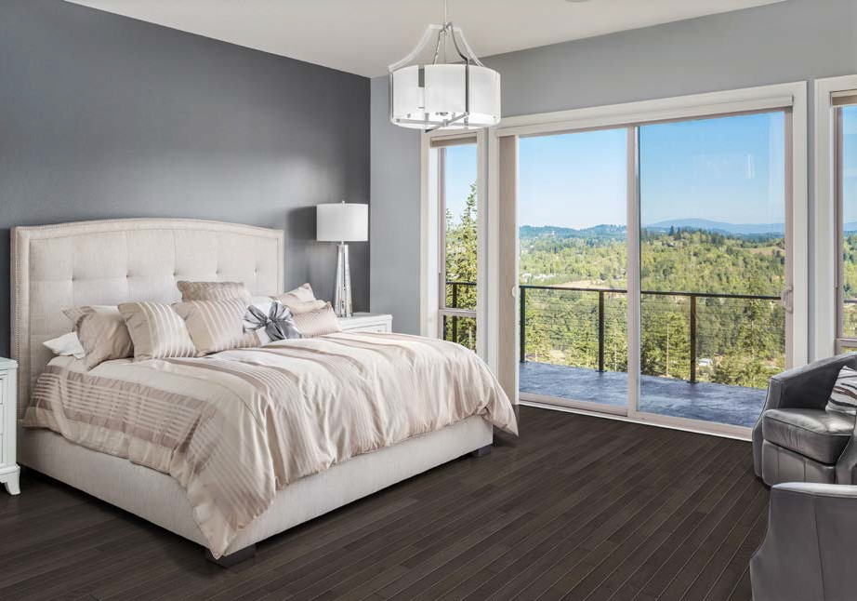

Enjoy living at its absolute finest. Tall ceilings and a soothing palette welcome you into this two-story masterpiece. This move-in ready beauty boasts two fireplaces, chef’s kitchen with stainless steel appliances, wine bar, dry bar, pantry, and spacious living room with walls of windows to stunning backyard views. Gorgeous master bedroom includes a full bath with his- and-her vanities, dual shower, and large walk- in closet. Perfect for entertaining, the backyard is beautifully landscaped and features a porch with outdoor BBQ, fire pit, and views looking out to the sparkling pool.

