# 

# 12707

EDGEWOOD DRIVE

*Atlanta, GA 30345*

# PRESENTED BY JEREMY NORMAN

YOUR LUXURY REAL ESTATE SPECIALIST

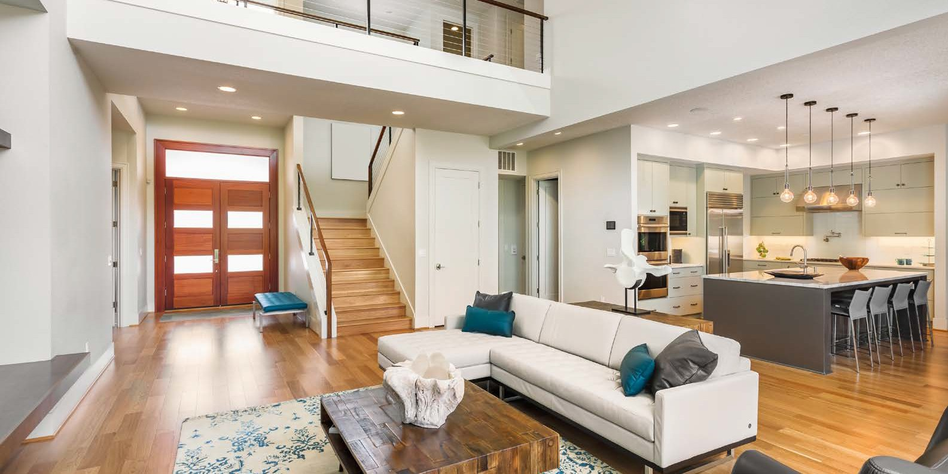

### 

### JEREMY NORMAN

Broker/CEO | Norman & Associates

CCIM, CLHMS

205.281.3934

470.223.1981

[jnorman@normanliving.com](mailto:jnorman@normanliving.com)

www.normanliving.com



**NORMAN &**

**ASSOCIATES**

**REAL ESTATE SOLUTIONS**

2295 Parklake Drive NE, Suite 440

Atlanta, GA 30345





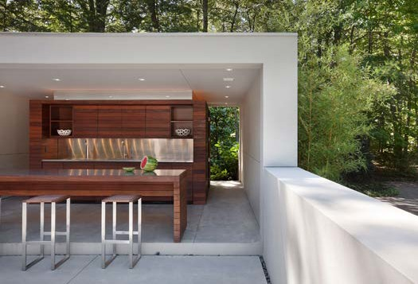

*If you would like*

*to have your home*

*professionally marketed,*

*call Jeremy*

*Norman today at*

*205.281.3934*

Published by REAL Marketing (REM) | [www.REALMarketing4You.com](http://www.REALMarketing4You.com/) | 858.952.4280 | ©2019 This brochure is not intended to solicit properties already listed for sale nor intended to cause a breach of an existing agency relationship. E&OE covered.

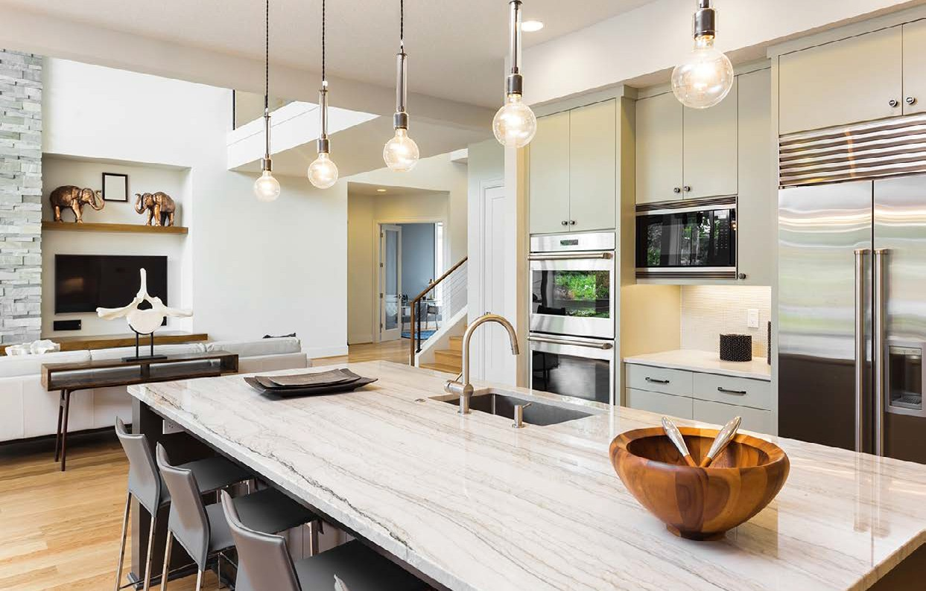

PERFECT

CONTEMPORARY

*Masterpiece*

Enjoy living at its absolute finest. This two-story masterpiece boasts two fireplaces, chef’s kitchen with stainless steel appliances, wine bar, pantry, and spacious living room with walls of windows to the stunning backyard. Gorgeous master features a full bath with large walk-in closet. The backyard is beautifully landscaped and features a porch with outdoor BBQ, fire pit, and sparkling pool.

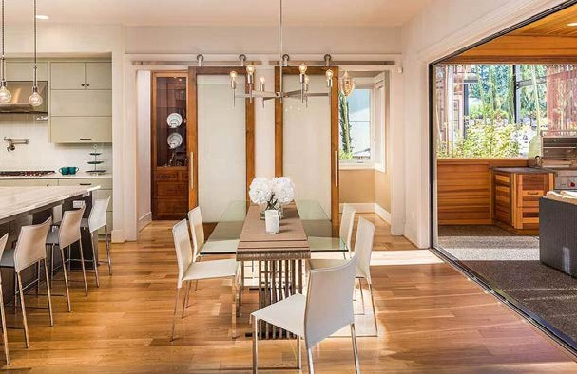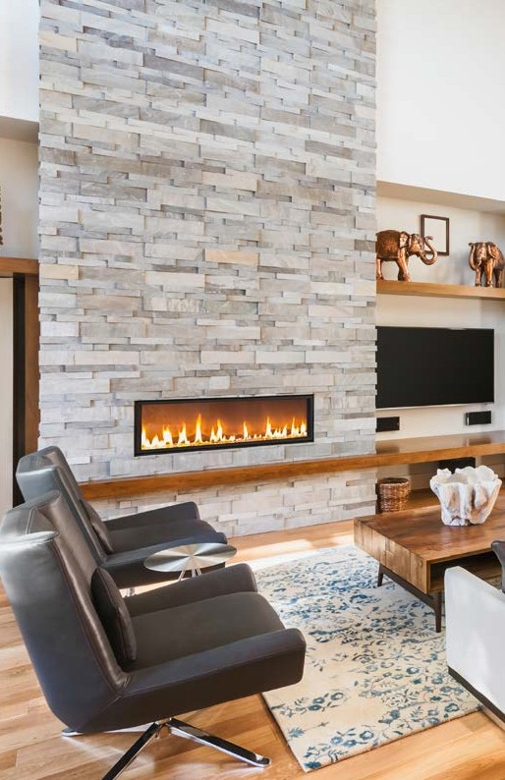

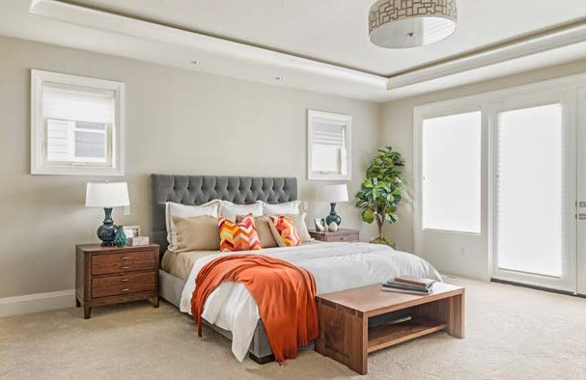

|  |  |  |  |
| --- | --- | --- | --- |
| 5 | 3 | 4,321 | 6,970 |
| Beds | Baths | Square Feet | Square Foot Lot |

MODERN

*Sophistication*

### OFFERED AT $1,897,000