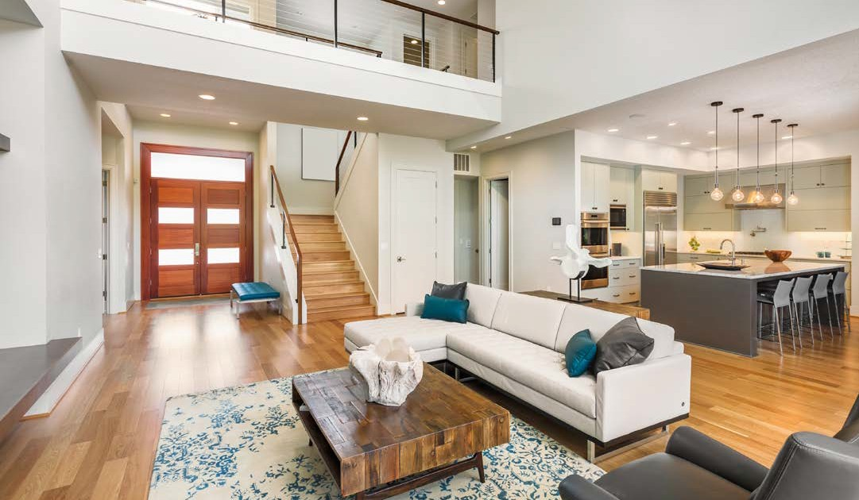
JUST LISTED
12707 Edgewood Drive | Atlanta, GA 30345

2295 Parklake Drive NE, Suite 440
Atlanta, GA 30345

JEREMY NORMAN
Broker/CEO | Norman & Associates CCIM, CLHMS
205.281.3934
470.223.1981
jnorman@normanliving.com www.normanliving.com

Christopher and Stephanie,
If you are looking to sell, let me help you achieve exceptional results.
Call me today at 615.330.3149.
Published by REAL Marketing (REM) www.REALMarketing4You.com | 858.952.4280 | ©2019
This postcard is not intended to solicit properties already listed for sale nor intended to cause a breach of an existing agency relationship. E&OE covered.

PRESENTED BY JEREMY NORMAN
Your Luxury Real Estate Specialist

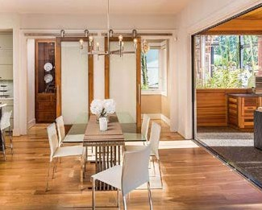
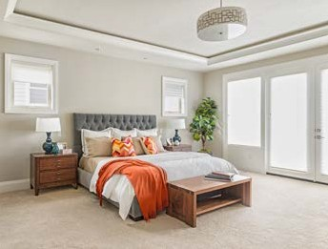
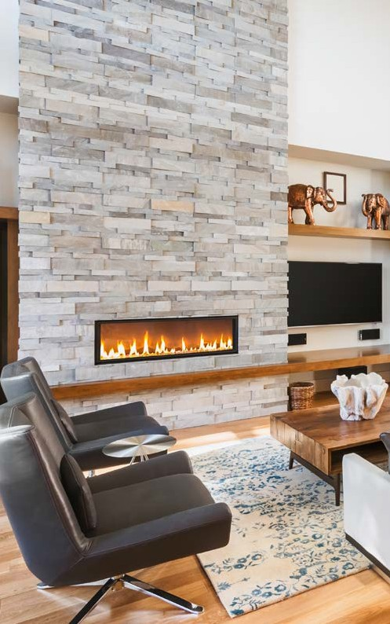

12707 EDGEWOOD DRIVE
ATLANTA, GA 30345

OFFERED AT $1,897,000

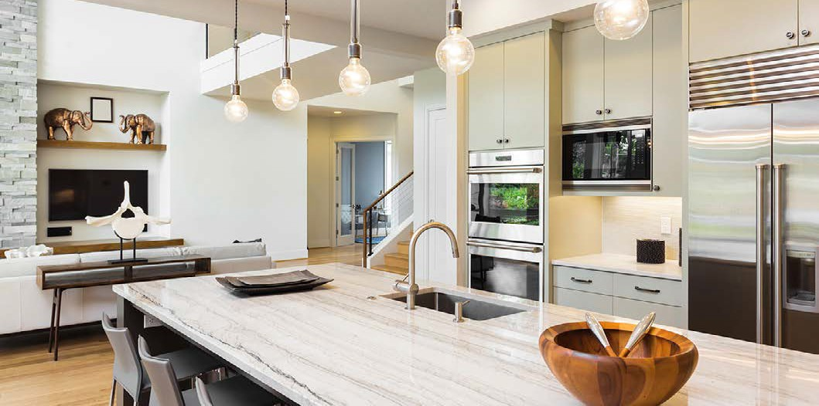
5
Beds
3
Baths

4,321
Square Feet

6,970
Square Foot Lot

Living at its absolute finest. This two-story masterpiece boasts two fireplaces, chef’s kitchen with stainless steel appliances, wine bar, pantry, and spacious living room with walls of windows to the stunning backyard. Gorgeous master features a full bath with large walk-in closet. The backyard is beautifully landscaped and features a porch with outdoor BBQ, fire pit, and sparkling pool.
MODERN
Sophistication

MODERN
Sophistication

