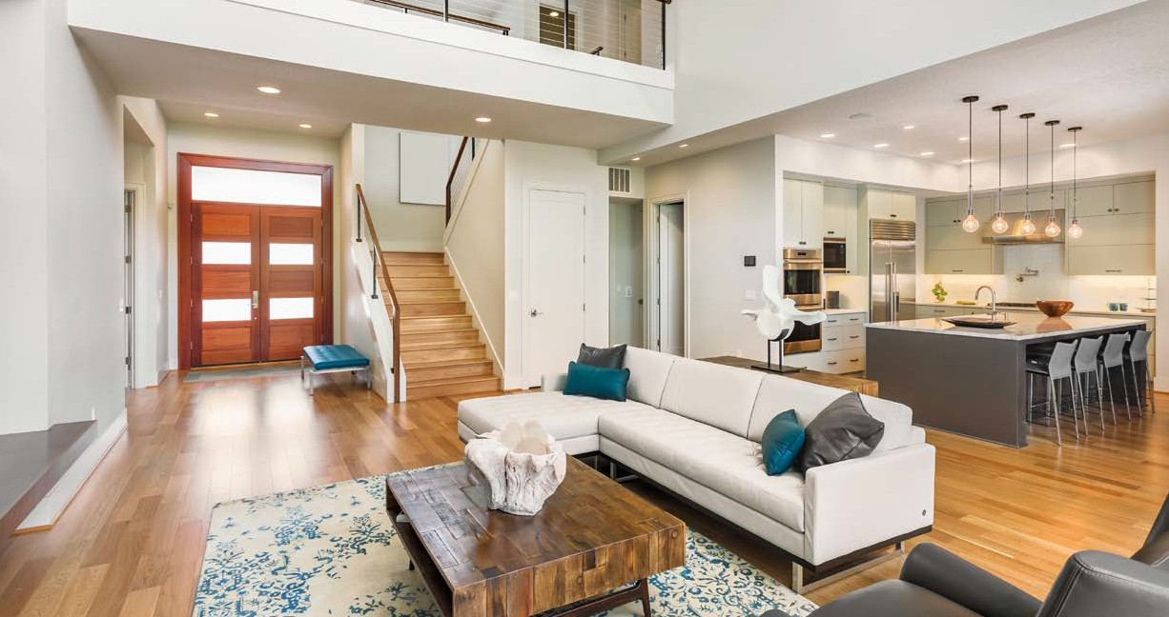



JUST

SOLD

*12707 Edgewood Drive | Atlanta, GA 30345*

JEREMY NORMAN NEGOTIATED THE SALE OF THIS HOME

FOR 100% OF CLIENT ASKING PRICE





JEREMY

NORMAN

Broker/CEO | Norman & Associates

CCIM, CLHMS

205.281.3934

470.223.1981

[jnorman@normanliving.com](mailto:jnorman@normanliving.com)

www.normanliving.com



PARKVIEW ESTATES

HOMES ARE IN HIGH DEMAND









**NORMAN &**

**ASSOCIATES**

**REAL ESTATE SOLUTIONS**

2295 Parklake Drive NE, Suite 440

Atlanta, GA 30345

Published by REAL Marketing (REM) | [www.REALMarketing4You.com](http://www.REALMarketing4You.com/) | 858.952.4280 | ©2019

This postcard is not intended to solicit properties already listed for sale nor intended to cause a breach of

an existing agency relationship. E&OE covered.

Christopher and Stephanie,

Several buyers missed out on my clients’ home and are still looking to buy in

Parkview Estates. If you are thinking of selling, contact me today at 205.281.3934.