JEREMY NORMAN
Broker/CEO | Norman & Associates CCIM, CLHMS
205.281.3934
470.223.1981
jnorman@normanliving.com www.normanliving.com
2295 Parklake Drive NE, Suite 440
Atlanta, GA 30345

12707
EDGEWOOD DRIVE
Atlanta, GA 30345

Christopher and Stephanie,
If you would like to have your home professionally marketed, call Jeremy Norman today at 205.281.3934.

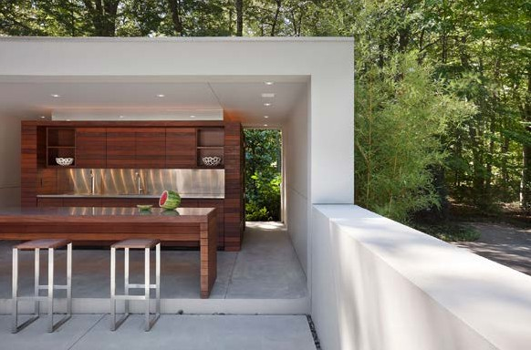
PRESENTED BY
JEREMY NORMAN
Your Luxury Real Estate Specialist

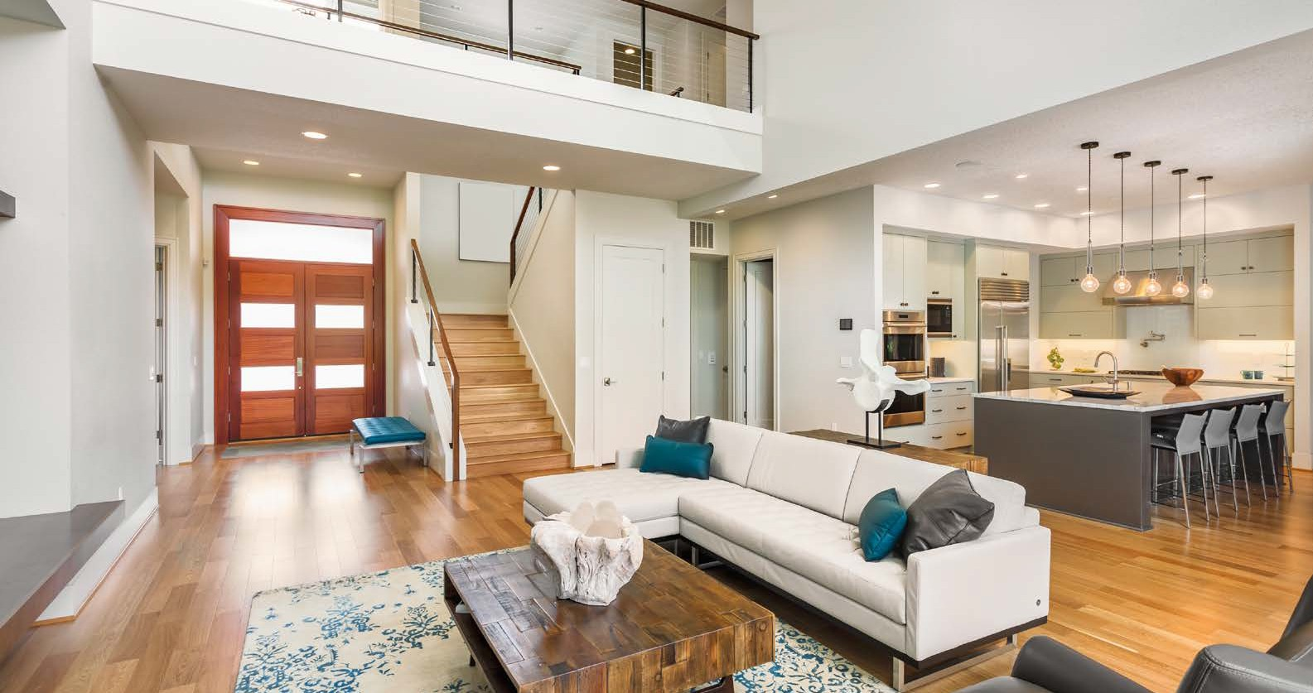

Published by REAL Marketing (REM) | www.REALMarketing4You.com | 858.952.4280 | ©2019

This brochure is not intended to solicit properties already listed for sale nor intended to cause a breach of an existing agency relationship. E&OE covered.
PREPARED ESPECIALLY FOR
CHRISTOPHER AND STEPHANIE WILLIAMSON

PERFECT
CONTEMPORARY
Masterpiece

12707 EDGEWOOD DRIVE
ATLANTA, GA 30345

OFFERED AT $1,897,000

6,970
Square Foot Lot
4,321
Square Feet
3
Baths
5
Beds

Enjoy living at its absolute finest. Tall ceilings and a soothing palette welcome you into this two-story masterpiece. This move-in ready beauty boasts two fireplaces, chef’s kitchen with stainless steel appliances, wine bar, dry bar, pantry, and spacious living room with walls of windows to stunning backyard views. Gorgeous master bedroom includes a full bath with his-and-her vanities, dual shower, and large walk-in closet. Perfect for entertaining, the backyard is beautifully landscaped and features a porch with outdoor BBQ.
MODERN
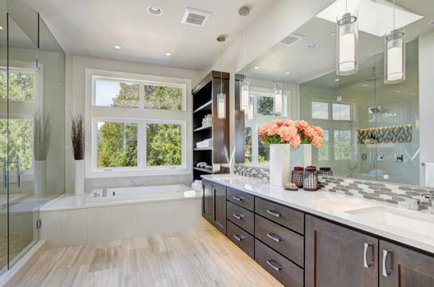
Sophistication
