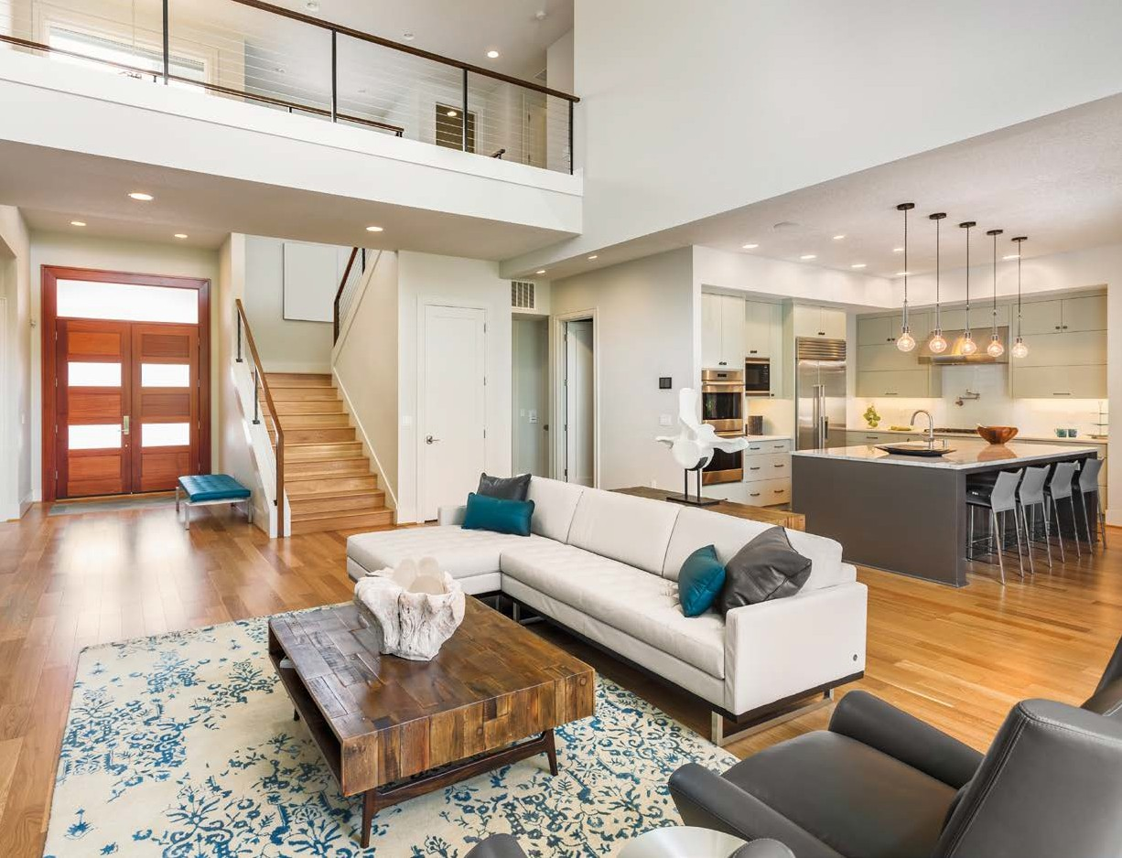

12707
EDGEWOOD DRIVE
Atlanta, GA 30345

PRESENTED BY
JEREMY NORMAN
Your Luxury Real Estate Specialist

PREPARED ESPECIALLY FOR
CHRISTOPHER AND STEPHANIE WILLIAMSON

JEREMY NORMAN
Broker/CEO | Norman & Associates CCIM, CLHMS
205.281.3934
470.223.1981
jnorman@normanliving.com www.normanliving.com

2295 Parklake Drive NE, Suite 440
Atlanta, GA 30345

PERFECT
CONTEMPORARY
Masterpiece

5
Beds

3
Baths

4,321
Square Feet

6,970
Square Foot Lot

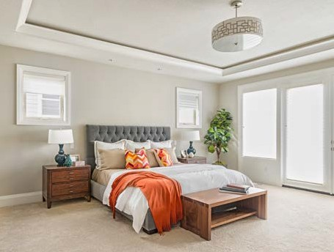

Enjoy living at its absolute finest. This two-story masterpiece boasts two fireplaces, chef’s kitchen with stainless steel appliances, wine bar, pantry, and spacious living room with walls of windows to the stunning backyard. Gorgeous master features a full bath with large walk-in closet. The backyard is beautifully landscaped and features a porch with outdoor BBQ, fire pit, and sparkling pool.

OFFERED AT $1,897,000

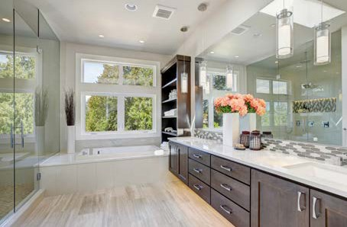
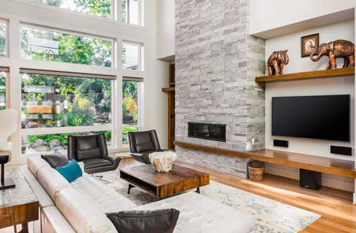
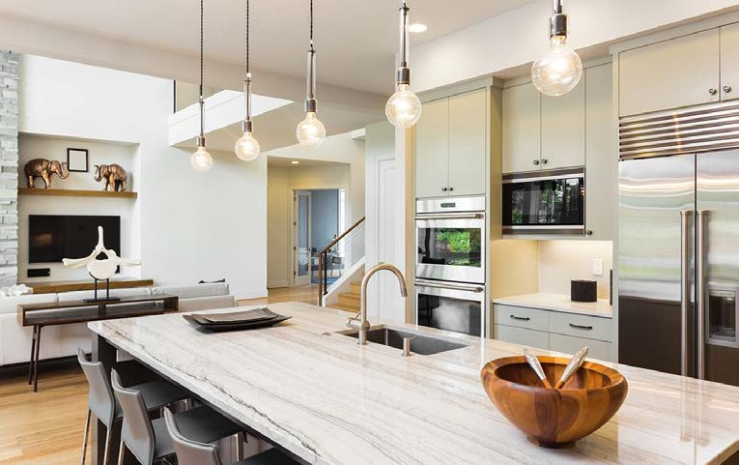

Christopher and Stephanie,
If you would like to have your home professionally marketed, call Jeremy Norman today at 205.281.3934.
Published by REAL Marketing (REM) | www.REALMarketing4You.com | 858.952.4280 | ©2019
This brochure is not intended to solicit properties already listed for sale nor intended to cause a breach of an existing agency relationship. E&OE covered.

