## PERFECT

## CONTEMPORARY

## *Masterpiece*

## 

12707 EDGEWOOD DRIVE

*Atlanta, GA 30345*

|  |  |  |  |
| --- | --- | --- | --- |
| 5 | 3 | 4,321 | 6,970 |
| Beds | Baths | Square Feet | Square Foot Lot |

Enjoy living at its absolute finest. This two-story masterpiece boasts two fireplaces, chef’s kitchen with stainless steel appliances, wine bar, pantry, and spacious living room with walls of windows to the stunning backyard. Gorgeous master features a full bath with large walk-in closet. The backyard is beautifully landscaped and features a porch with outdoor BBQ, fire pit, and sparkling pool.

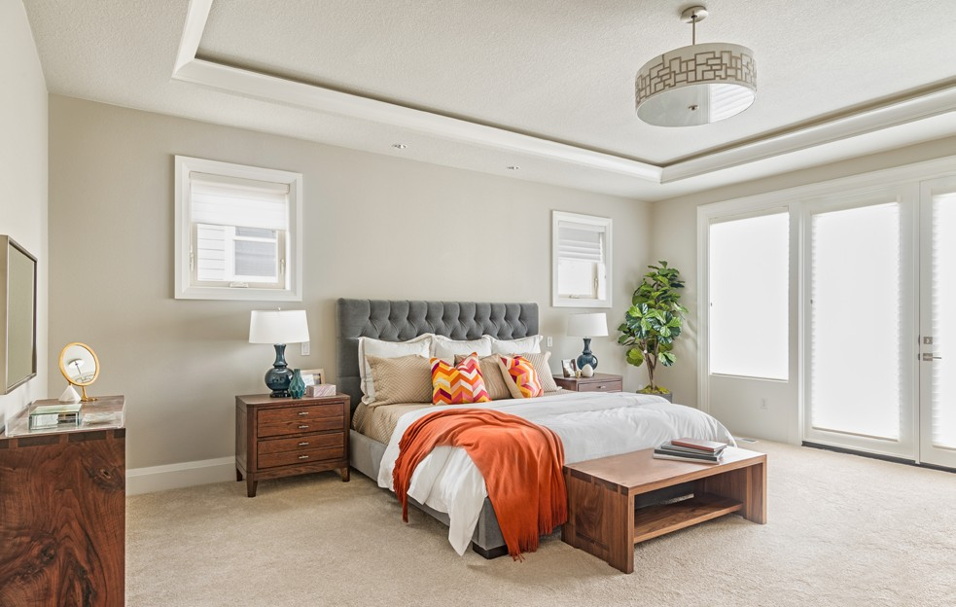

OFFERED AT $1,897,000

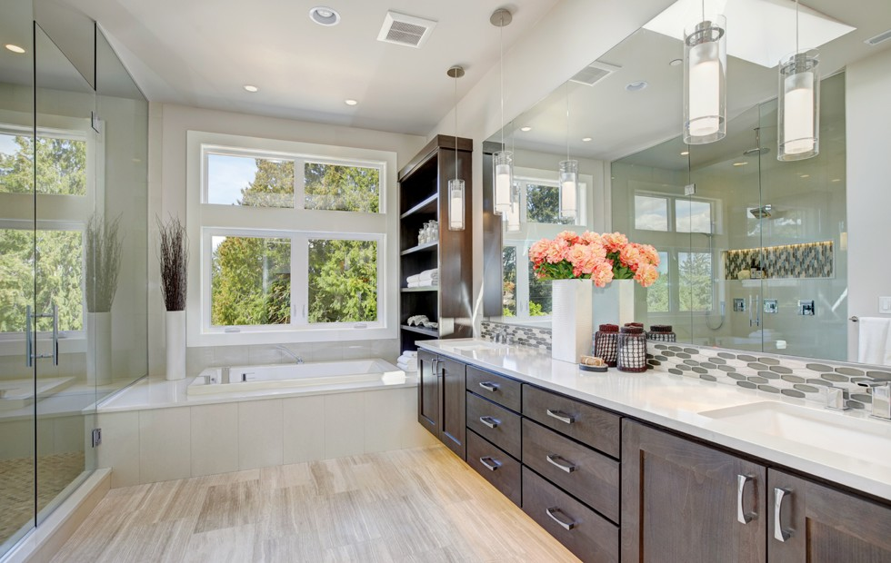

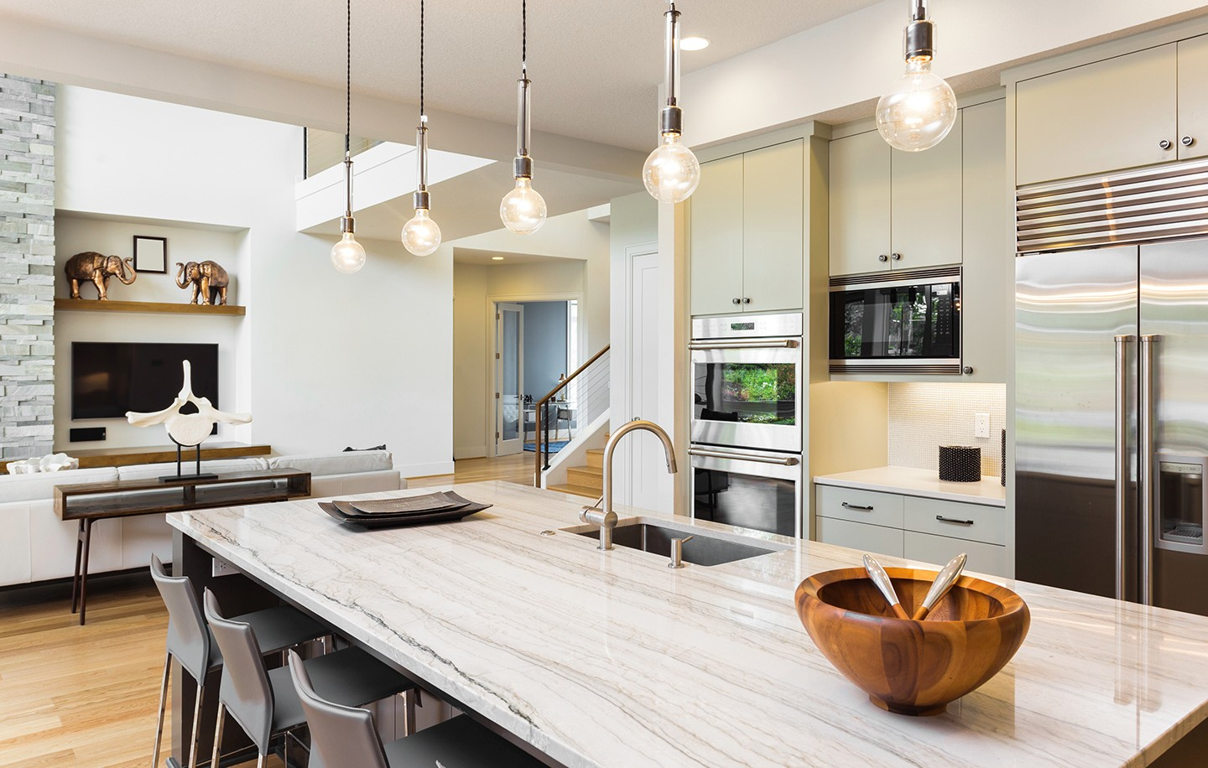

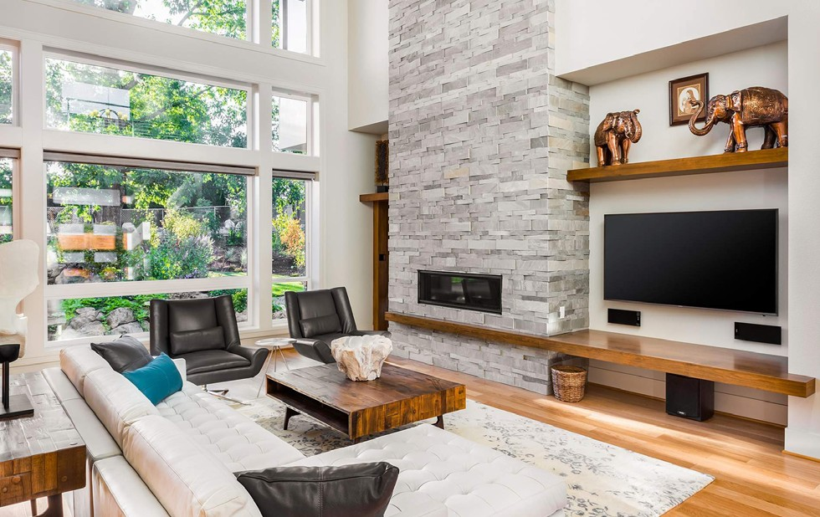

**NORMAN &**

**ASSOCIATES**

**REAL ESTATE SOLUTIONS**

*If you would like more information on this magnificent home, call Jeremy Norman at 205.281.3934.*

This brochure is not intended to solicit properties already listed for sale nor intended to cause a breach of an existing agency relationship. E&OE covered.

JEREMY NORMAN

Broker/CEO | Norman & Associates

CCIM, CLHMS

205.281.3934

470.223.1981

jnorman@normanliving.com

www.normanliving.com



2295 Parklake Drive NE, Suite 440 | Atlanta, GA 30345