**NORMAN &**

**ASSOCIATES**

**REAL ESTATE SOLUTIONS**

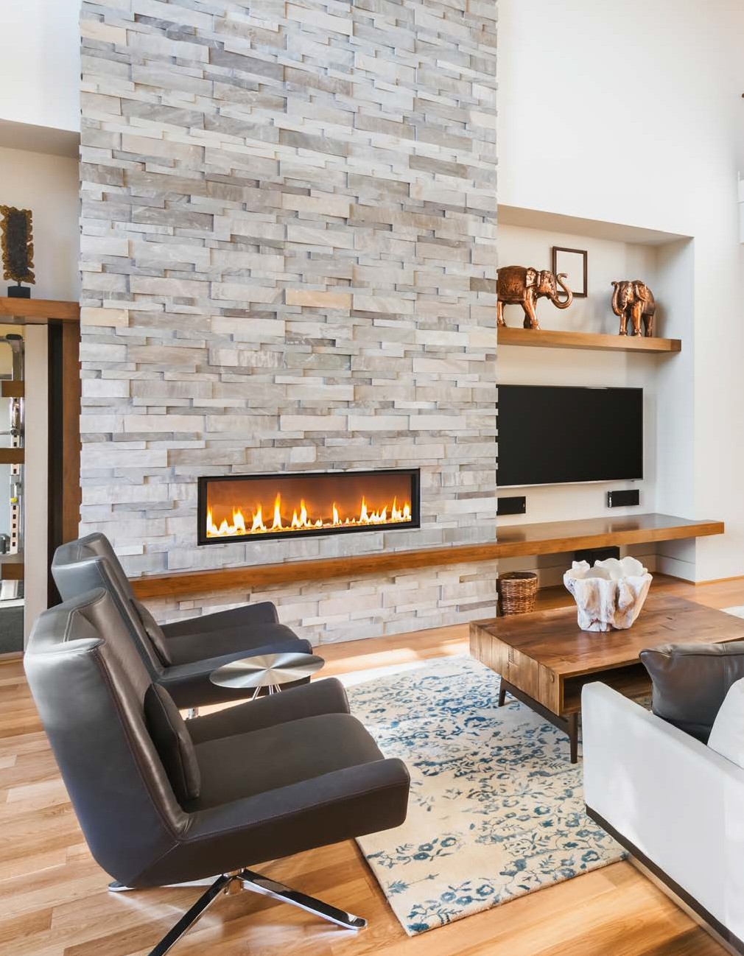



12707

EDGEWOOD

DRIVE

*Atlanta, GA 30345*

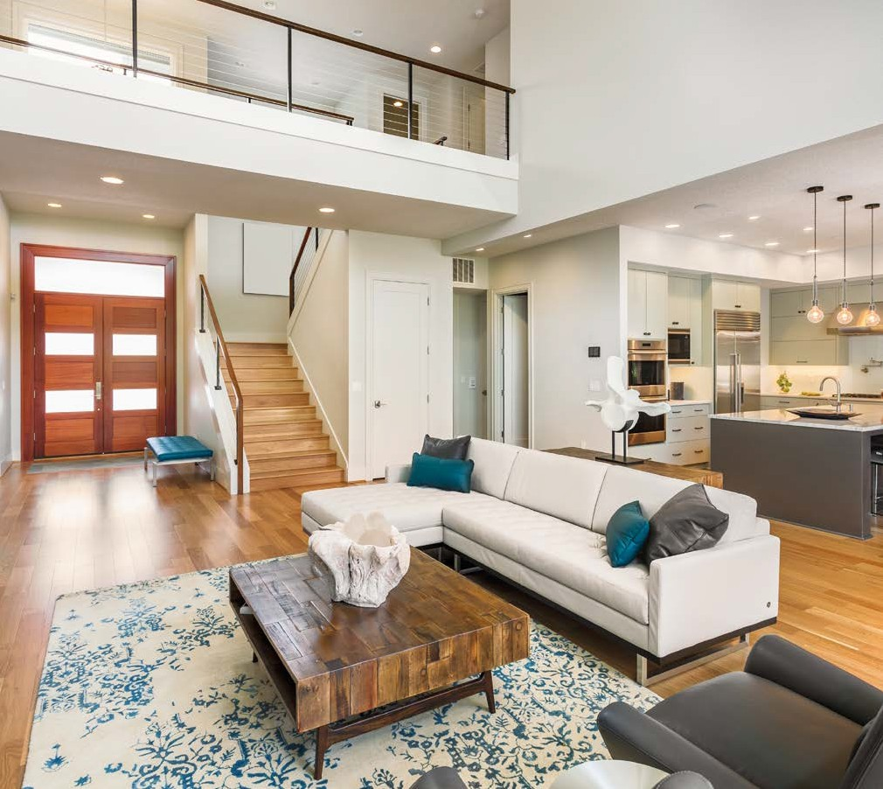





JEREMY NORMAN

Broker/CEO | Norman & Associates

CCIM, CLHMS

205.281.3934

470.223.1981

[jnorman@normanliving.com](mailto:jnorman@normanliving.com)

[www.normanliving.com](http://www.normanliving.com/)

# 

2295 Parklake Drive NE, Suite 440

Atlanta, GA 30345

*Christopher and Stephanie,*

*If you would like to have your home professionally marketed, call Jeremy Norman today at 205.281.3934.*

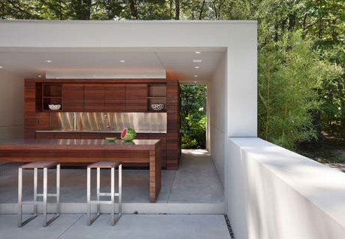

M O D E R N

*Sophistication*

PRESENTED BY

JEREMY NORMAN

## Your Luxury Real Estate Specialist

PREPARED ESPECIALLY FOR

CHRISTOPHER AND STEPHANIE WILLIAMSON



Published by REAL Marketing (REM) | [www.REALMarketing4You.com](http://www.REALMarketing4You.com/) | 858.952.4280 | ©2019

This brochure is not intended to solicit properties already listed for sale nor intended to cause a breach of an existing agency relationship. E&OE covered.

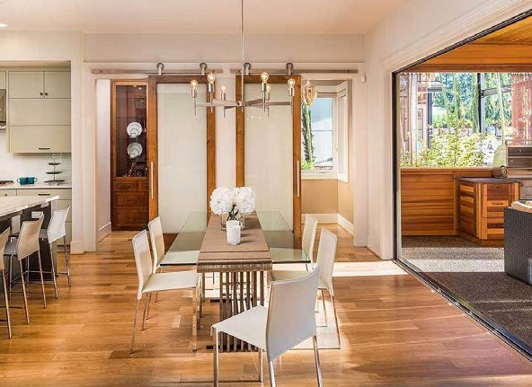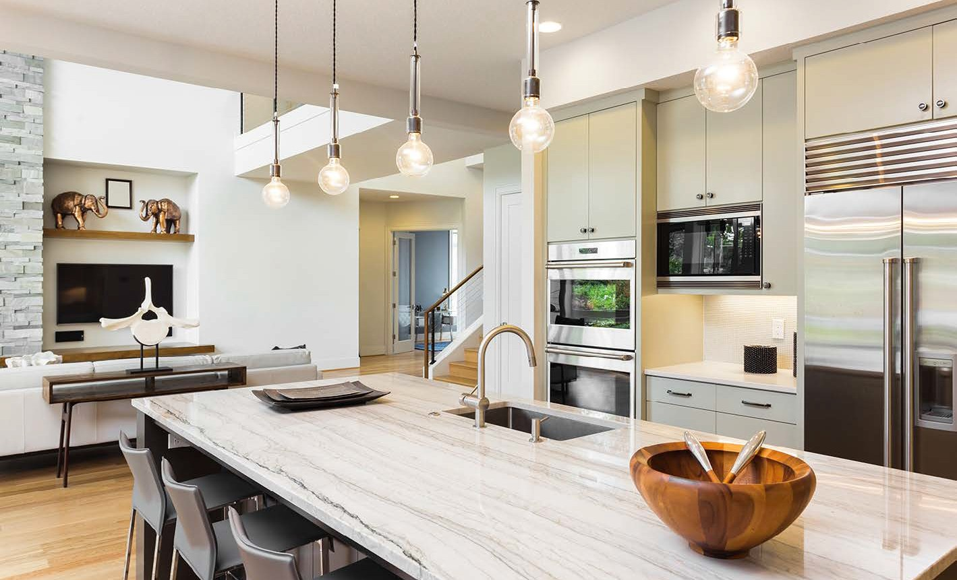

PERFECT

CONTEMPORARY

*Masterpiece*

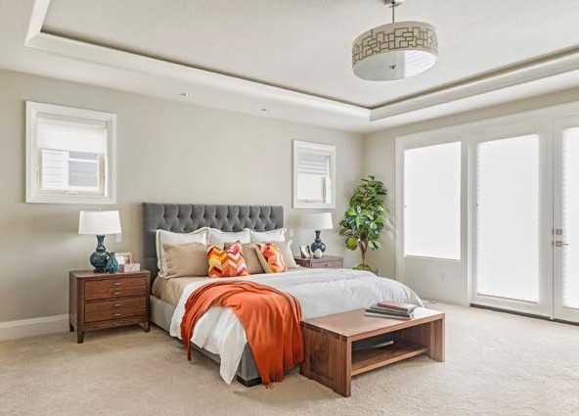

6,970

Square Foot Lot

4,321

Square Feet

3

Baths

5

Beds

OFFERED AT $1,897,000

12707 EDGEWOOD DRIVE

ATLANTA, GA 30345

Enjoy living at its absolute finest. Tall ceilings and a soothing palette welcome you into this two-story masterpiece. This move-in ready beauty boasts two fireplaces, chef’s kitchen with stainless steel appliances, wine bar, dry bar, pantry, and spacious living room with walls of windows to stunning backyard views. Gorgeous master bedroom includes a full bath with his-and-her vanities, dual shower, and large walk-in closet. Perfect for entertaining, the backyard is beautifully landscaped and features a porch with outdoor BBQ, fire pit, and views looking out to the sparkling pool.

